**Live Life with Health Awareness**

**Come See What (B. I. D.) is All About!**

**B= Blood Pressure and its relationship to Strokes**

**I= Immunizations, When and Why (Flu, RSV, Shingles, Pneumonia, COVID)**

**D= Diabetes Medication: Doctors Prescriptions VS Online & Orders**

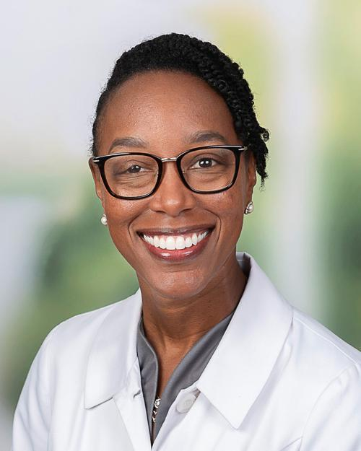

The facilitator for this workshop is **Dr. Lachelle Y. Campbell,** a family medicine doctor in Glen Allen, Virgina. She is affiliated with multiple hospitals in the area, including St. Mary’s, Mary Washington Hospital and Bon Secour. She has expertise in treating diabetes, anxiety disorders, hypertension, among other conditions. She is also a license ordained minister. She completed her Master of Divinity Degree Samuel Dewitt Proctor School of Theology at Virginia Union University. A question-and-answer period will be given after her presentation.

**The Health Awareness Workshop is scheduled for: Date: March 15, 2025, from 10:00 AM to 12:00 Noon, at Ebenezer Baptist Church, 14476 Scotchtown Rd. Beaverdam, VA. 23015, where Rev. Dr. John Kinney is the pastor. A donation to the Mattaponi Scholarship Fund for students is requested. A boxed lunch will be provided after the workshop.**